Chapter 19, Problem 61.

For the bridge circuit in Fig. 19.108, obtain:

(a) the z parameters
(b) the h parameters
(c) the transmission parameters

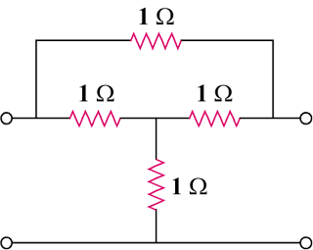

Figure 19.108
For Prob. 19.61.

